LOYOLA COLLEGE (AUTONOMOUS), CHENNAI – 600 034
U.G. DEGREE EXAMINATION - GENERAL ENGLISH
FIRST SEMESTER – APRIL 2011

EL 1052/1050 - ENGLISH THROUGH PRINT AND VISUAL MEDIA

Date : 26-04-2011 Dept. No. Max. : 100 Marks

Time : 9:00 - 12:00

- Answer all the questions given below: 10x10=100

- Read the following snippet carefully and expand it into a full news story.
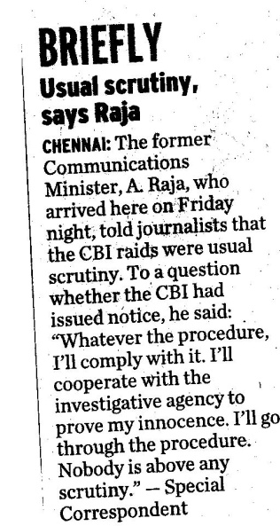

- Read the given news story carefully and condense it into a snippet. Frame three new head lines also.
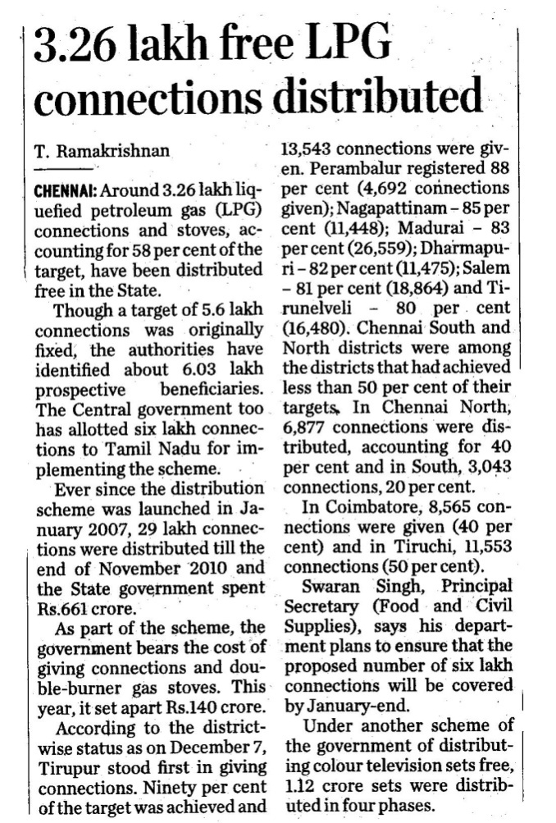

- Why is the letters to the editor column considered a vital space in any standard news paper? Respond to the letter given below.

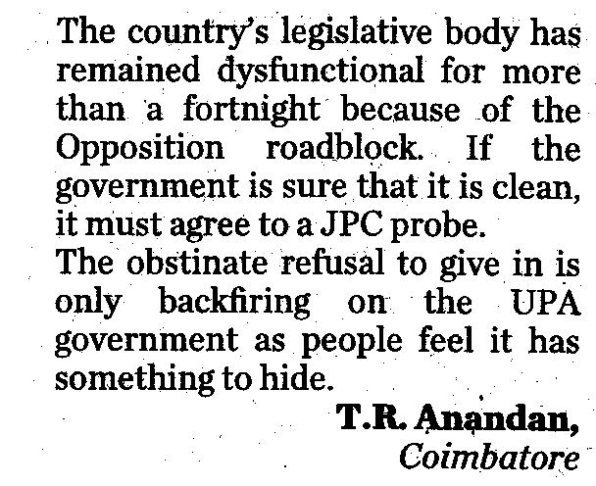

- Examine the cartoon given below carefully and prepare a write up based on the caption and issue highlighted in it.

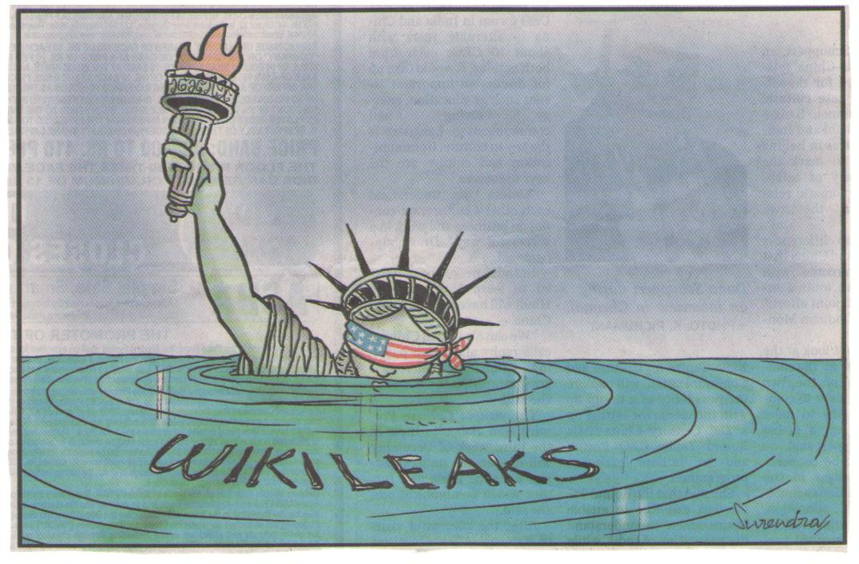

- Read the following editorial from The Hindu and analyse it in terms of the stand taken, views expressed and the writing style with examples from the text.

- Given below is an advertisement for washing machine. Does it contain all the features required for an effective ad? Analyse and write your comment.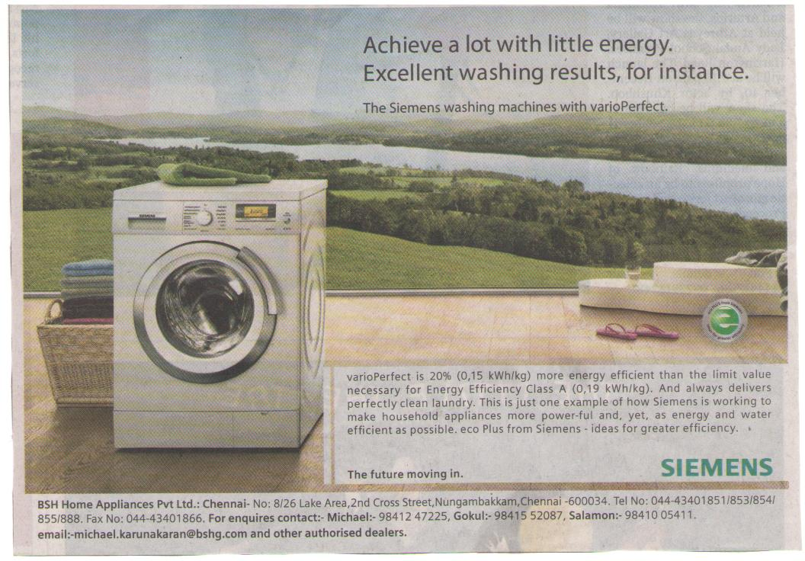

- Write a book review for the book News and Views and give suggestions for improvement.

- How does Shaw portray the class divisions in English society in his play Pygmalion?

- The play Pygmalion focuses on the role of education in personal and social uplift – Discuss.

- Compare and contrast the film My Fair Lady with the play Pygmalion.
#########

